
Project Title:
AI Model to Predict Student Dropout Risk
Submitted by:
Musa Bin Abdullah 233576
Muhammad Danial 233588
Abdullah Altaf 233558
Group No:
09
Submitted to:
Madam Atika
Contents:
1. Abstract: 4
2. Introduction: 4
3. Objectives: 4
3.1 Primary Objectives: 4
3.2 Secondary Objectives 5
4. DATASET DESCRIPTION 5
4.1 Primary Dataset Source 5
4.2 Key Academic Features 5
4.3 Data Enhancement for Academic Management 6
5.Innovations: 6
1) Real-Time Dropout Risk Dashboard (MongoDB + AI Integration) 6
2) Early-Warning System Using Continuous Monitoring 6
3) Personalized Recommendations for At-Risk Students 6
6. PROBLEM STATEMENT 7
6.1 Current Challenges 7
6.2 Impact Analysis 7
7. METHODOLOGY 7
7.1 Academic Assessment System 7
7.2 Data Collection & Preparation 8
7.3 Machine Learning Approach 8
7.4 System Architecture 8
8.Workflow: 9
1) Data Collection: 9
2) Prepossessing: 9
3) Model Training: 9
4) Testing 9
5) Integration: 9
6) Dashboard: 9
8.1 Workflow Diagram: 9
9. EXPECTED OUTCOMES & DELIVERABLES 10
9.1 Technical Deliverables 10
9.2 Functional Deliverables 11
10. SUCCESS METRICS 11
10.1 Technical Success Criteria 11
10.2 Academic Success Criteria 11
11. ETHICAL CONSIDERATIONS 12
11.1 Academic Integrity 12
12. CONCLUSION 12

Project Title:
AI Model to Predict Student Dropout Risk

Abstract:
This project aims to build an AI model to predict which students are at risk of dropping out. The model uses student data such as grades, attendance, study hours, and family background to make predictions.
The system includes a real-time dashboard, early-warning alerts, and personalized recommendations to help teachers and counselors take timely action.

Introduction:
Student dropout is a serious problem in many schools and universities. Students often leave due to low grades, financial issues, or personal problems. This affects their future opportunities and lowers the reputation of the institution.
Our project will develop an AI model to predict students at risk of dropping out. By analyzing data on attendance, grades, study habits, and family background, the system can help teachers and management take early action to reduce dropout rates.
The project implements an end-to-end solution that processes historical academic data from the "Higher Education Predictors of Student Retention" dataset, applies XGBoost machine learning algorithms, and delivers actionable insights through three interactive dashboards. The system includes comprehensive grading management (A,B,C,D,F,I), GPA calculation, and assignment/quiz tracking to enable proactive interventions and reduce dropout rates.

Objectives:

3.1 Primary Objectives:
- Develop predictive model with 85%+ accuracy using XGBoost
- Implement comprehensive ABCDFI grading system with GPA calculation
- Create three real-time dashboards (Admin, Teacher, Student)
- Establish assignment and quiz performance tracking
- Enable re-examination system for eligible students

3.2 Secondary Objectives
- Automate grade calculation and risk assessment
- Provide personalized improvement recommendations
- Track assignment and quiz performance trends
- Generate institutional academic reports

4. DATASET DESCRIPTION

4.1 Primary Dataset Source
Dataset: "Higher Education Predictors of Student Retention" from Kaggle/UCI Repository
Records: 4,424 student records from 2008-2019 academic years
Features: 36 comprehensive academic and demographic attributes
Target Variable: Student Status (Graduate, Dropout, Enrolled)

4.2 Key Academic Features
Core Academic Metrics:
- Curricular units 1st & 2nd sem (credited, enrolled, evaluations, approved, grade)
- Previous qualification grades and scores
- Application mode and course selection
- Daytime/evening attendance patterns
- Tuition fees status and scholarship information
Demographic & Socioeconomic Factors:
- Age at enrollment
- Marital status and nationality
- Mother's and Father's qualification and occupation
- Displaced status and educational special needs
- International student status
Economic Indicators:
- Unemployment rate
- Inflation rate
- GDP per capita

4.3 Data Enhancement for Academic Management
Added Academic Features:
- A/B/C/D/F/I grading system implementation
- GPA calculation and tracking
- Assignment submission and scoring data
- Quiz performance metrics
- Re-examination eligibility tracking

5.Innovations:
Our project includes some unique and modern features that make it different from normal prediction s systems:

Real-Time Dropout Risk Dashboard (MongoDB + AI Integration)
The system connects the AI model with MongoDB, which allows live updates whenever new data (like grades or attendance) is added. The dashboard instantly shows each student’s risk level — High, Medium, or Low.

Early-Warning System Using Continuous Monitoring
The model keeps checking student performance over time. If a student’s marks or attendance suddenly drops, it will automatically alert teachers or counselors, so they can help before the student leaves.

Personalized Recommendations for At-Risk Students
The system will not only show risk but also give suggestions — for example, study more hours, meet a counselor, or attend extra classes. This helps both students and teachers to take better steps for improvement.

6. PROBLEM STATEMENT

6.1 Current Challenges
Educational institutions face significant challenges in student retention:
- Reactive approaches identifying struggling students only after academic failure
- Manual grade calculation and tracking of assignments/quizzes
- No standardized re-examination system for borderline students
- Inefficient resource allocation for student support services
- Lack of early warning mechanisms for potential dropouts

6.2 Impact Analysis
- Individual Level: Dropped students face limited career opportunities
- Institutional Level: Reduced graduation rates affect reputation
- Academic Level: Inconsistent grading and assessment practices

7. METHODOLOGY

7.1 Academic Assessment System
Grading Criteria (ABCDFI System):
- A (90-100%): Excellent - 4.0 GPA
- B (80-89%): Good - 3.0 GPA
- C (70-79%): Satisfactory - 2.0 GPA
- D (60-69%): Pass - 1.0 GPA
- F (Below 60%): Fail - 0.0 GPA
- I (Incomplete): Special re-examination eligibility
Re-examination Eligibility for "I" Grade:
- Assignment average ≥ 70%
- Quiz average ≥ 70%
- Mid-term score ≥ 70%
- Final exam score < 50%
- Maximum achievable grade after re-exam: "C"
Assignment & Quiz Management:
- Weighted scoring system (Assignments: 40%, Quizzes: 30%, Final: 30%)
- Performance trend analysis
- Automated grade calculation
- Progress monitoring alerts

7.2 Data Collection & Preparation
Primary Dataset Processing:
- Data cleaning and missing value treatment
- Feature engineering for academic performance
- GPA calculation and normalization
- Temporal validation splitting

7.3 Machine Learning Approach
Algorithm Selection: XGBoost (Primary Model)
Model Development:
- Feature importance analysis focusing on academic performance
- Hyperparameter optimization
- Cross-validation with stratified sampling
- Performance metrics: Accuracy, Recall, F1-Score

7.4 System Architecture
Technical Stack:
- Backend: Python, XGBoost, Scikit-learn
- Database: MongoDB for academic records
- Frontend: Streamlit for interactive dashboards
- Deployment: Local server with cloud backup
System Components:
- Grade calculation and management module
- Assignment/quiz tracking system
- XGBoost prediction engine
- Three-role dashboard system
- Alert and notification system

8.Workflow:
- Data Collection: Get student data from Kaggle or other sources.
- Prepossessing: Clean missing data and choose main features.
- Model Training: Train ML models using Python.
- Testing: Check which model performs best.
- Integration: Connect model with MongoDB for real-time updates.
- Dashboard: Show live predictions and alerts.

8.1 Workflow Diagram:

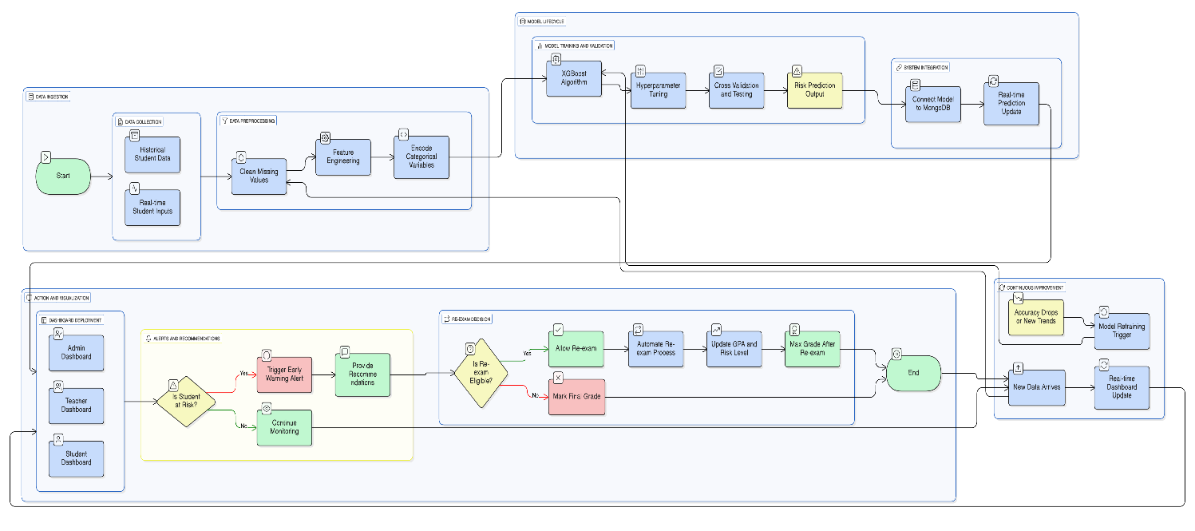

9. EXPECTED OUTCOMES & DELIVERABLES

9.1 Technical Deliverables
Academic Management System:
- Automated ABCDFI grade calculation
- GPA computation and tracking
- Assignment and quiz performance analytics
- Re-examination eligibility automation
Machine Learning Models:
- Trained XGBoost prediction model
- Feature importance analysis report
- Model performance documentation
Software System:
- Three specialized dashboards:
  - Admin Dashboard: Institutional analytics, grade reports, retention rates
  - Teacher Dashboard: Grade entry, assignment tracking, student risk monitoring
  - Student Dashboard: Personal grades, GPA tracking, improvement suggestions

9.2 Functional Deliverables
Grading & Assessment:
- Real-time grade calculation
- Automated GPA computation
- Assignment and quiz performance tracking
- Re-examination management
Prediction Capabilities:
- Early risk identification based on academic performance
- Individual student risk profiling using grade patterns
- Course-specific performance analytics
- Trend analysis for academic improvement

10. SUCCESS METRICS

10.1 Technical Success Criteria
- Model accuracy: >85% prediction accuracy
- Grade calculation accuracy: 100% precise
- System reliability: Consistent performance
- User satisfaction: Intuitive grade management

10.2 Academic Success Criteria
- Accurate ABCDFI grade implementation
- Proper GPA calculation and tracking
- Effective assignment/quiz performance monitoring
- Successful re-examination process management

11. ETHICAL CONSIDERATIONS

11.1 Academic Integrity
- Transparent grading criteria implementation
- Fair re-examination eligibility assessment
- Consistent assignment evaluation standards
- Bias-free performance assessment

12. CONCLUSION
This project proposal presents a comprehensive solution for student dropout prediction with integrated academic management capabilities. By combining robust XGBoost machine learning with a complete ABCDFI grading system, assignment/quiz tracking, and GPA management, the system provides educational institutions with powerful tools for academic monitoring and early intervention.
The inclusion of three specialized dashboards ensures appropriate access for different stakeholders, while the re-examination system provides fair assessment opportunities for borderline students. With clear implementation phases and achievable success metrics, this project demonstrates strong potential for improving student retention through data-driven academic management.
The system's focus on practical academic needs—grade management, performance tracking, and proactive intervention—makes it particularly valuable for educational institutions seeking to enhance their student success initiatives through technological innovation.

The integer values you're seeing for student information fields are likely the result of feature importance scoring from your machine learning model. This means your model (probably a Random Forest or similar tree-based model) has analyzed each feature and assigned a numerical score showing how much it contributes to predicting student dropout.
🔍 What These Numbers Represent
Score Range | Interpretation
0-5 | Low importance - Features that contribute minimally to predictions
5-15 | Medium importance - Features that moderately influence predictions
15+ | High importance - Key features that strongly affect dropout prediction
📊 Analyzing Your Specific Results
From your data:
- Top predictors (Score > 15):
  - Father's qualification (16.46) - Most important
  - Mother's qualification (12.32)
  - Curricular units 2nd sem (without evaluations) (12.00)
- Mid-range predictors (Score 5-15):
  - Unemployment rate (11.57)
  - Course (9.90)
  - Curricular units 1st sem (evaluations) (8.30), etc.
- Low predictors (Score < 5):
  - Debtor (0.11) - Least important
  - Gender (0.35), Scholarship holder (0.25), etc.

